

**MINOR-1 PROJECT**

**END-TERM REPORT**

For

Cache Simulator

Submitted By

|  |  |  |
| --- | --- | --- |
| **Specialization** | **SAP ID** | **Name** |
| CCVT | 500093013 | Atin Anant |
| CCVT | 500096448 | Piklu De |
| CCVT | 500096554 | Shubham Jaiswal |
| CCVT | 500093054 | Ashmit Panwar |

  Department of Systemics

School Of Computer Science

UNIVERSITY OF PETROLEUM & ENERGY STUDIES,

DEHRADUN- 248007. Uttarakhand

Ms. Shahina Anwarul Dr. Hitesh Sharma

**Project Mentor Cluster Head**

**1. Project Title**

Cache Simulator

**2. Abstract**

Modern computer systems rely heavily on caches to bridge the performance gap between fast processors and slower main memory. Cache simulators are essential tools for computer architects and software developers to understand and optimize memory hierarchies. This abstract introduces a Cache Simulator, a versatile software tool designed to model and analyse cache behaviour. Our Cache Simulator provides a user-friendly interface, enabling users to configure cache parameters such as cache size, associativity, and replacement policies. It simulates memory access patterns, tracking cache hits and misses, and generates insightful performance metrics. Researchers can use it to study cache performance under various scenarios, architects can explore design trade-offs, and software developers can optimize code to maximize cache utilization. This tool's versatility extends its applicability to diverse computing domains, from embedded systems to high-performance computing clusters. Additionally, it aids in teaching cache concepts in computer science education. With the Cache Simulator, users can gain deep insights into memory access behaviour and employ this knowledge to design more efficient and responsive computing systems.

**3. Introduction**

In the fast-paced world of modern computing, optimizing memory access is paramount for achieving high-performance systems. Central processing units (CPUs) operate at speeds far surpassing the capabilities of main memory, creating a substantial performance gap. Cache memory, nestled between the CPU and main memory, serves as a crucial bridge, storing frequently accessed data and instructions to expedite processing. Understanding cache behaviour and its impact on overall system performance is a fundamental challenge in computer architecture and software development. To address this challenge, Cache Simulators have emerged as indispensable tools, enabling architects, researchers, and developers to model, analyse, and optimize memory hierarchies. This introduction presents Cache Simulator as an essential software tool tailored to the intricacies of cache behaviour analysis. We delve into the critical role of caches in contemporary computing, discuss the challenges they pose, and highlight the need for simulation tools to explore and enhance memory access efficiency.

**3.1. The Importance of Caches in Modern Computing:**

In the realm of computer architecture, caches are a linchpin in the quest for high-performance computing. Processors' rapid evolution has outstripped improvements in memory access times, leading to a stark performance gap. To bridge this gap, caches are introduced as intermediary memory hierarchies. These hierarchies consist of multiple cache levels, with the closest and smallest cache, L1, residing closest to the CPU core. The subsequent levels, L2, L3, and so on, increase in size but incur longer access latencies. Caches exploit the principle of temporal and spatial locality, ensuring that frequently accessed data and instructions are readily available, thus reducing the time CPUs spend waiting for memory fetches.

**3.2. Challenges in Cache Behaviour Analysis:**

Understanding cache behaviour is a multifaceted challenge due to the complex interplay of cache parameters and the inherent non-determinism of memory access patterns. Cache behaviour depends on factors like cache size, associativity, line size, and replacement policies. Each parameter choice can significantly impact cache hit rates and, consequently, system performance. Moreover, the dynamic and unpredictable nature of real-world workloads makes it challenging to predict cache behaviour analytically. These challenges underscore the importance of simulation tools that can replicate cache operations under varying conditions.

**3.3. The Need for Cache Simulators:**

Cache simulators are pivotal tools that cater to the diverse needs of computer architects, researchers, and software developers. They offer a controlled environment to experiment with cache configurations and memory access patterns, providing insights into how different parameters affect cache performance. Researchers can use simulators to study cache behaviour under a range of scenarios, helping them explore new cache designs and optimizations. Architects can evaluate trade-offs between cache size, associativity, and replacement policies to fine-tune system architectures for specific workloads. Software developers can employ cache simulators to profile and optimize code, ensuring that it maximizes cache utilization for superior execution speed.

**3.4. Introducing Cache Simulator:**

Cache Simulator is a versatile software tool designed to address the aforementioned challenges and cater to the diverse needs of computing professionals. This tool offers an intuitive user interface, allowing users to configure cache parameters and memory access patterns easily. It simulates cache operations, meticulously tracking cache hits and misses, and provides comprehensive performance metrics. Users can experiment with various cache configurations and assess their impact on memory access efficiency, offering a holistic view of cache behaviour.

**3.5. Applications Across Computing Domains:**

Cache Simulator's flexibility and applicability extend across a wide spectrum of computing domains. From embedded systems to high-performance computing clusters, understanding and optimizing cache behaviour is vital. It empowers engineers to design systems that meet stringent performance requirements and helps researchers unravel the mysteries of cache performance in diverse settings. Furthermore, Cache Simulator serves as a valuable educational tool, aiding in the teaching and comprehension of cache concepts in computer science courses.

**4. Literature Review:**

One particularly important part of almost any processor is the cache hierarchy. While some simulators support simulating a whole processor, including the cache hierarchy, cores, and on-chip interconnect, others may only support simulating the cache hierarchy. This survey provides a detailed discussion on 28 CPU cache simulators, including popular or recent simulators. We compare between all of these simulators in four different ways: major design characteristics, support for specific cache design features, support for specific cache-related metrics, and validation methods and efforts. [1].

The new method, static cache simulation, analyzes a program for a given cache configuration and determines prior to execution time if an instruction reference will always result in a cache hit or miss. At run time, counters are incremented to provide the execution frequency of portions of code. In addition, the cache behaviour is simulated for references that could not be predicted statically. The dynamic simulation employs a novel view of the cache by updating local state information associated with code portions. The total number of cache hits and misses can be inferred from the frequency counters at program exit.[2]

**5. Problem Statement:**

In the realm of computer architecture and system optimization, understanding cache behavior is crucial for achieving efficient and high-performance computing systems. Cache simulators are essential tools for evaluating and optimizing cache memory designs. However, there is a need for a new cache simulator project to address specific challenges and requirements.

**6. Objective**:

Design and implement a cache simulator that can simulate the behaviour of a cache memory system.

**Sub-objectives**

* The simulator should use algorithms like LRU, FIFO, or random for cache line replacement
* The simulator should be able to take as input the cache size, block size, associativity, and replacement policy.
* It should also be able to read a trace of memory accesses and simulate the behaviour of the cache for each access.
* The simulator should output statistics such as the number of cache hits, misses, and evictions. Additionally, the simulator should be able to visualize the state of the cache at any point in time.
* Assess the impact of cache optimizations on overall system performance.

**7. Methodology**:

The method we are using for making the project are:

The program starts by reading command line arguments, which include cache size, associativity, replacement policy, write-back policy, and an input file containing memory access traces.

**Data Structures:**

* Arrays: Used for cache lines, tag arrays, data arrays, and other metadata storage.
* Linked Lists: For implementing cache replacement policies like LRU (Least Recently Used) or FIFO (First-In-First-Out).
* Hash Tables: Useful for quick lookups in associative caches.

Memory traces obtained from real applications or benchmarks are essential for simulating cache behavior.

**Memory Access Traces:**

Memory traces obtained from real applications or benchmarks are essential for simulating cache behavior.

**Simulation Algorithms:**

* Direct-Mapped Cache Simulation: Uses simple indexing to find cache lines.
* Set-Associative Cache Simulation: Utilizes indexing and tag matching for associativity.
* Fully Associative Cache Simulation: Requires a more complex search to find cache lines.

**Replacement Policies:**

LRU (Least Recently Used): Evicts the least recently used cache line.

FIFO (First-In-First-Out): Evicts the oldest cache line.

**Random Replacement:**

Randomly selects a cache line for eviction.

**Prefetching Algorithms:**

Implement prefetching strategies to improve cache performance.

**Write Policies:**

Choose between write-through and write-back policies.

**Performance Metrics:**

* Hit Rate: The percentage of cache accesses that result in hits.
* Miss Rate: The percentage of cache accesses that result in misses.

**8. Flow chart:**

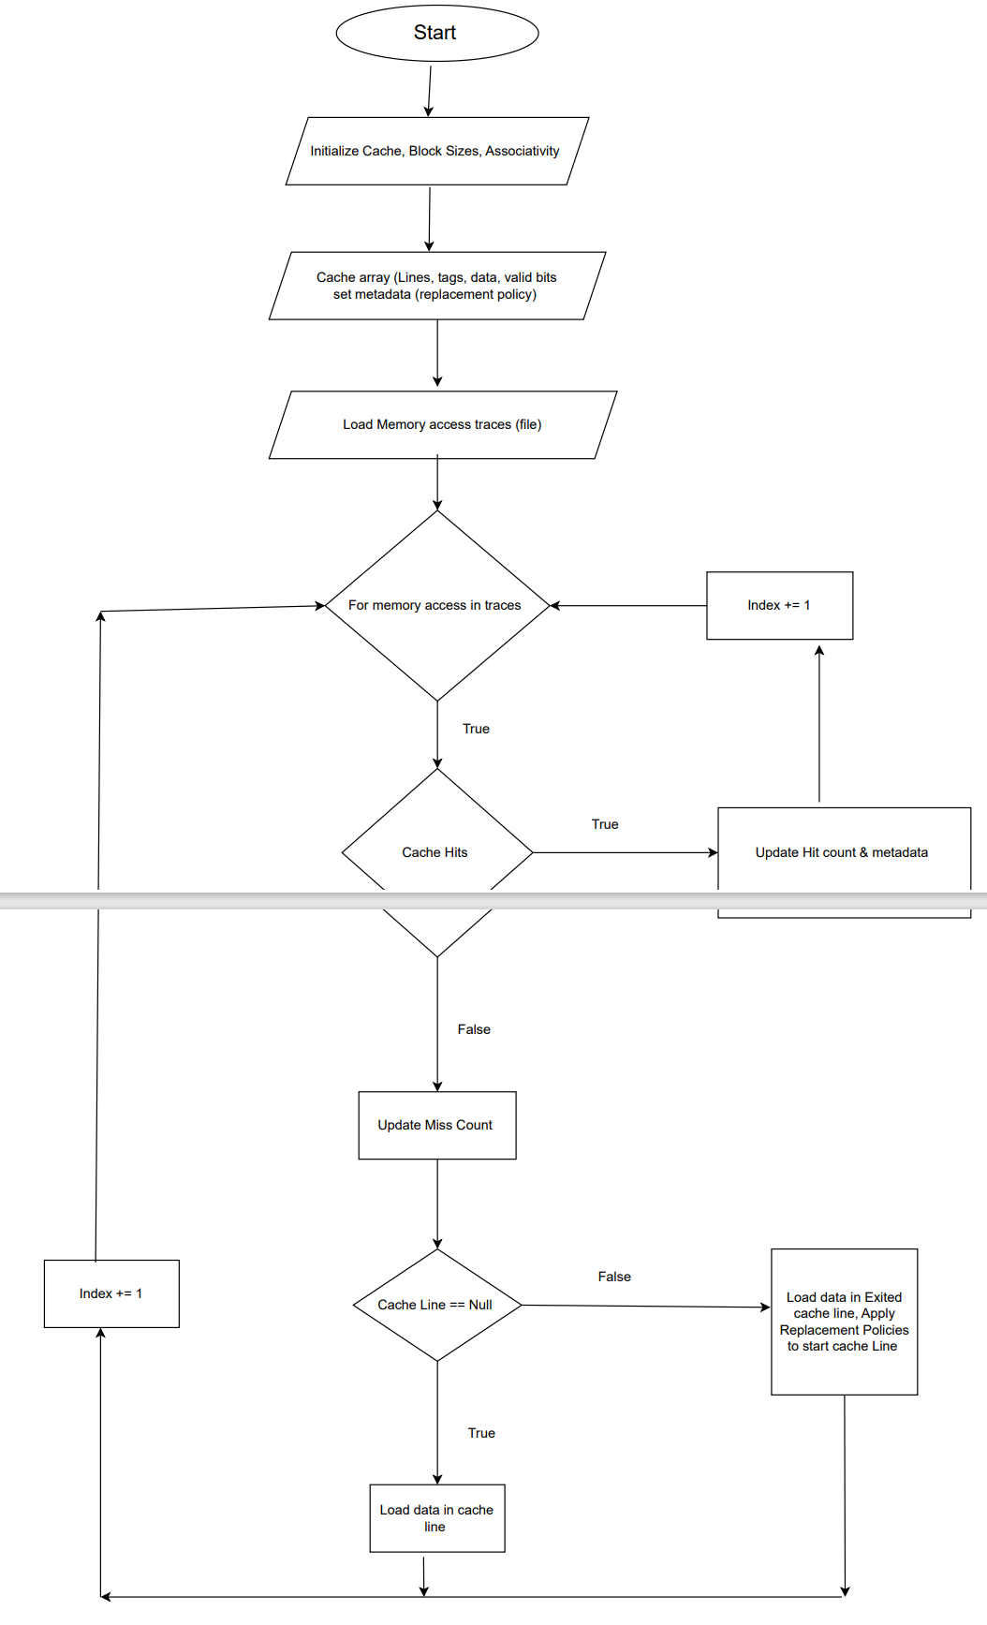

Fig 1: Flowchart

**9. Pert chart:**

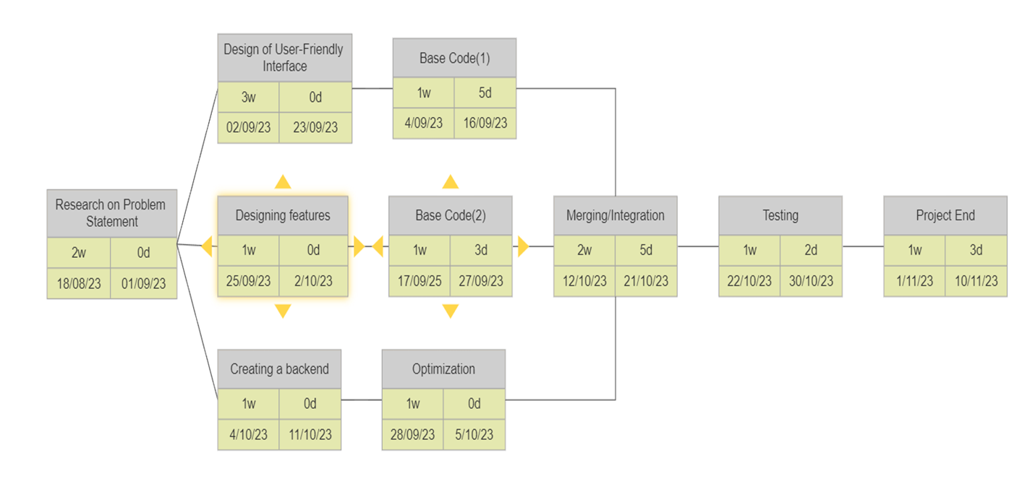

Fig2: Pert Chart

**10. Results:**

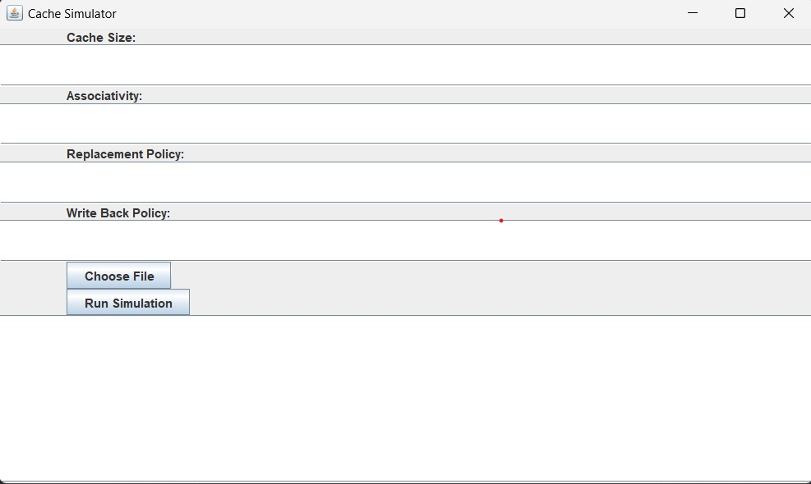

Fig3: Input Interface

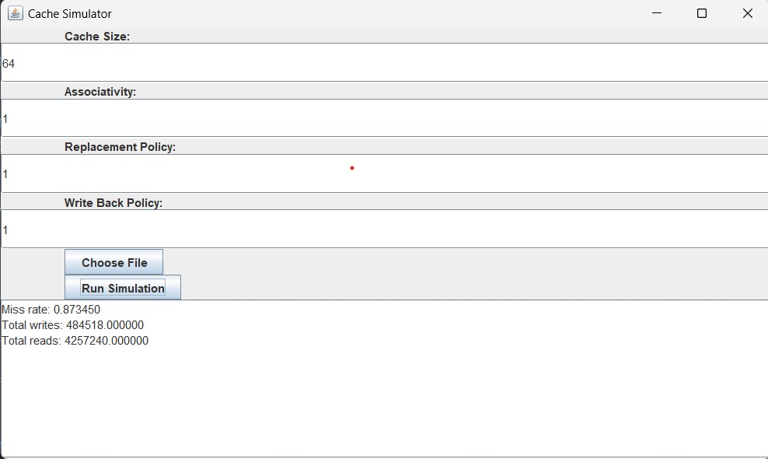

Fig4: Output Interface

**11.References:**

1. Brais, H., Kalayappan, R., & Panda, P. R. (2020). A survey of cache simulators. *ACM Computing Surveys (CSUR)*, *53*(1), 1-32.
2. Mueller, F., & Whalley, D. B. (1995, April). Fast instruction cache analysis via static cache simulation. In *Proceedings of Simulation Symposium* (pp. 105-114). IEEE.